Middle East Technical University

Electrical and Electronics Engineering

EE464 Static Power Conversion-II



Project-1: Simulation and Design of the Hardware Project

Instructor: Assist. Prof. Dr. Ozan KEYSAN

Student: Sadık AKYAR - 2093219

Sonay ULUKAYA - 2094597

İsmail ATASEVEN - 2030120

Date: 31.03.2019

Table of Contents

Introduction 3

Design of an Isolated Power Supply 4

Part-a 4

Part-b 6

Part-c 8

Part-d 10

Part-e 12

Part-f 14

Part-g 15

Part-f 15

Reference 15

# Introduction

In this project, simulation and design of the hardware project is completed. We chose the flyback converter topology which has 10V output voltage and 60W output power. Moreover, output voltage ripple must be smaller than the 4% and line & load regulation must be smaller than the 2%. In this report simulation results of our design and analysis of them can be found. Furthermore, magnetic design and analysis of transformer is also considered. In addition to them, preliminary components are selected.

# Design of an Isolated Power Supply

Specifications of the chosen topology which is Flyback Converter are:

* Input Voltage: 24V – 48V
* Output Voltage: -10V
* Output Power: 60W
* Output voltage ripple: 4%
* Line regulation: 2%
* Load regulation: 2%

We chose 100kHz as a switching frequency because we are planning to use the UC2845 controller whose typical frequency is 100kHz.

## Part-a

Following simulation results shows the steady-state operation of the flyback converter with given specifications. Calculation of magnetizing inductance (Lm=31.61µH), transformer turns ratio (15:15) and duty cycle will be shown in the following parts. Figure-1 shows the circuit diagram of the simulation and Figure-2&3 shows the output voltage & current waveforms for 24V input. Also, Figure-5&6 shows the output voltage & current waveforms for 48V input. Input current waveforms are also shown in Figure-4&7 for 24V&48V input voltage respectively.

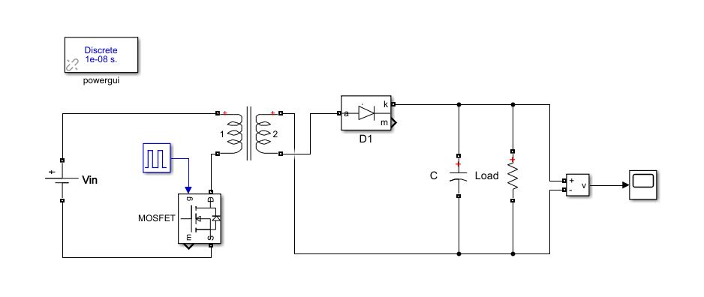

Figure 1: Circuit diagram of the flyback converter simulation

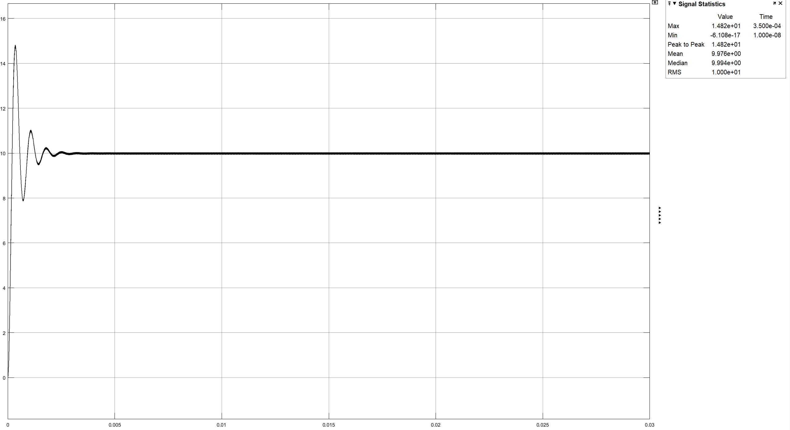

Figure 2: Output voltage waveform of the flyback converter (Vin=24V)

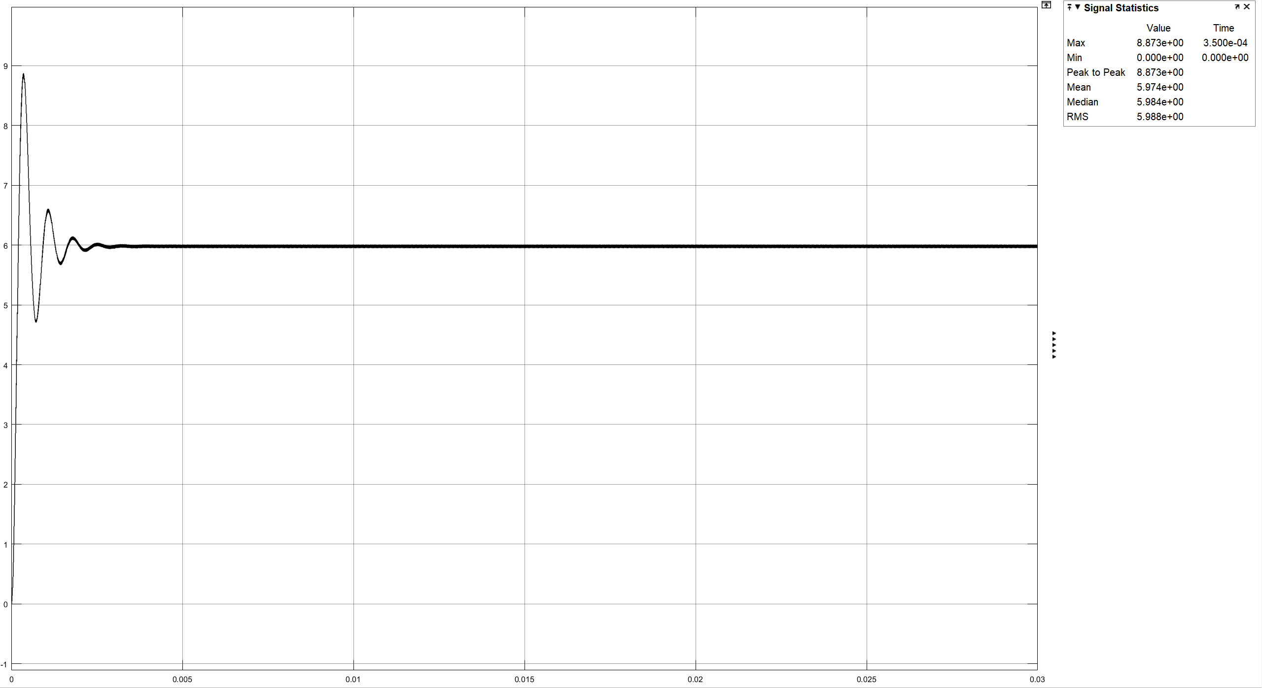

Figure 3: Output current waveform of the flyback converter (Vin=24V)

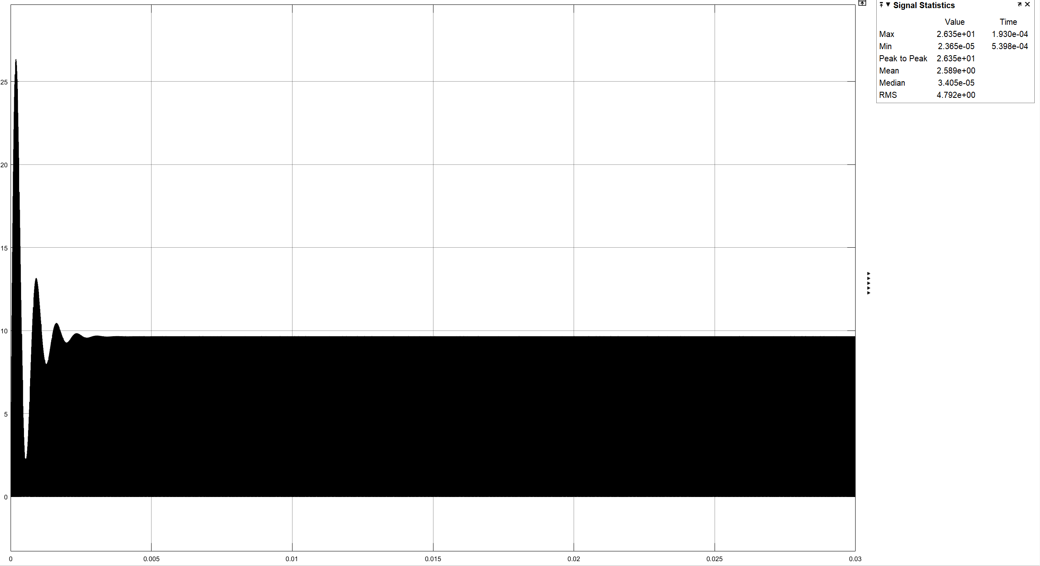

Figure 4: Input current waveform of the flyback converter (Vin=24V)

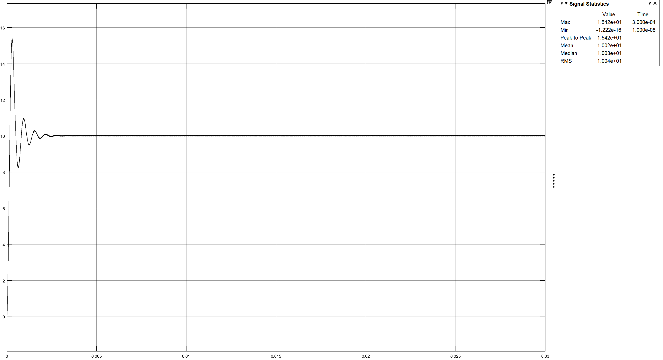

Figure 5: Output voltage waveform of the flyback converter (Vin=48V)

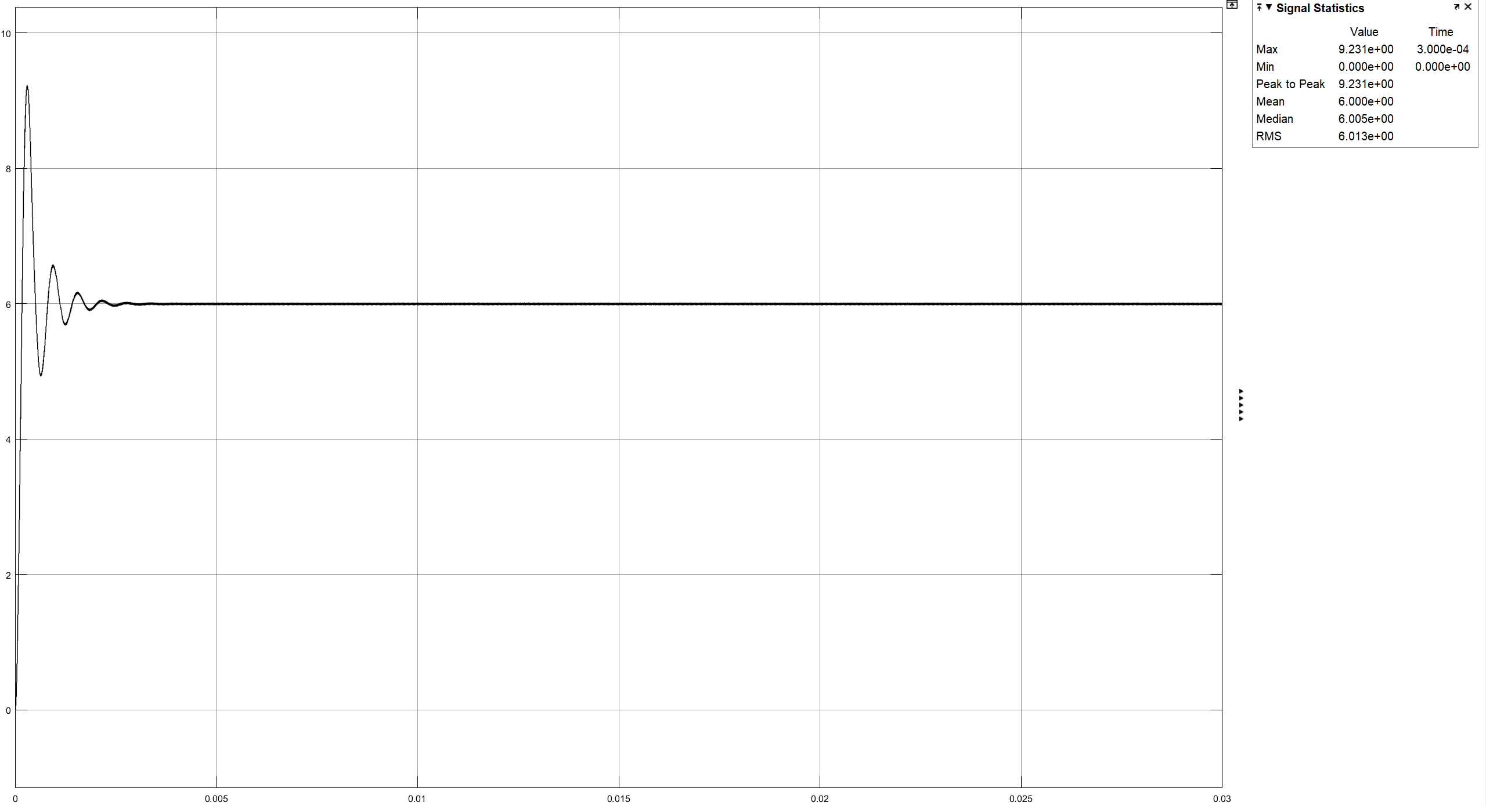

Figure 6: Output current waveform of the flyback converter (Vin=48V)

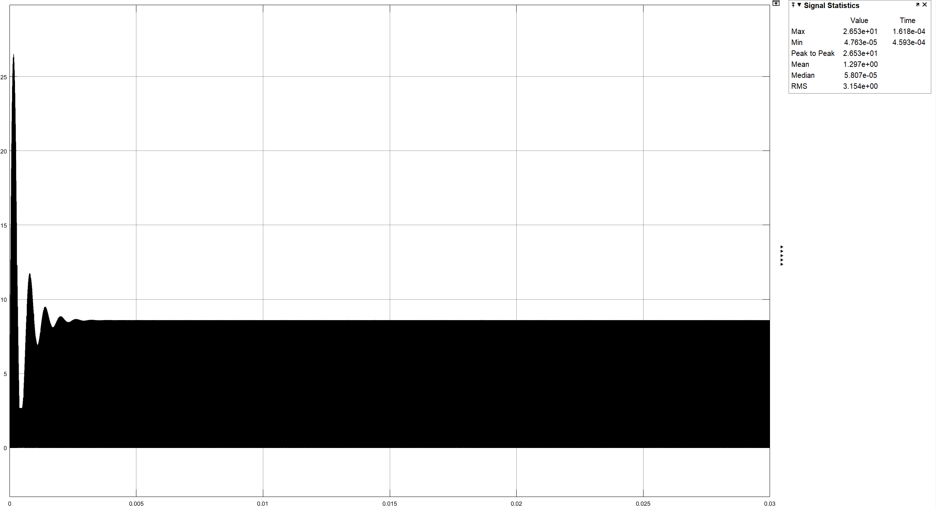

Figure 7: Input current waveform of the flyback converter (Vin=48V)

## Part-b

To adjust the output voltage, we decide to use 1:1 transformer because it also provides a small duty cycle for switching. According to that, duty cycle for 24V input voltage is 29.5% and 17.25% is for 48V input voltage. Below equations shows their calculations.

To calculate the magnetizing inductance of the transformer we assumed the current ripple of the Lm is 40%. Following equations shows the calculation of the minimum Lm value.

According to these values we chose the Magnetics-00K4022E090 E-core to decrease the number of turns because its AL value is high compared to the other cores. Following equations shows the number of turns calculation. (To complete the magnetic path, we are planning to use the two E-core which are connected each other. Because of that the AL of the core become half of it.)

Number of turns must be integer, so we chose 15 turns. With these turns and this core, magnetizing inductance is:

Maximum current pass through the transformer is 10.165A, so we chose the AWG-10 cable which can carry maximum 15A. (Area of the cable=5.26mm2 and Resistance=3.276392Ω/km). Copper resistance calculation is shown in the following equations.

To check, can cables fit the core wind area, we calculated the fill factor which is 57%, so all cables can easily fit the window area. Calculation of the fill factor is that:

Also, maximum B-field is checked to be sure about core is not saturated while working. Following equations shows that maximum B-field is 0.073T which means that core is not saturated (with the help of a Kool Mµ B-H curve).

Finally core loss is calculated. Core loss multiplier 300mW/cm3 is given in the datasheet for 100kHz and 0.07T, so;

Magnetizing resistance is taken 10kΩ and leakage inductance is taken as 1% of the magnetizing resistance for simulations.

# Part-c

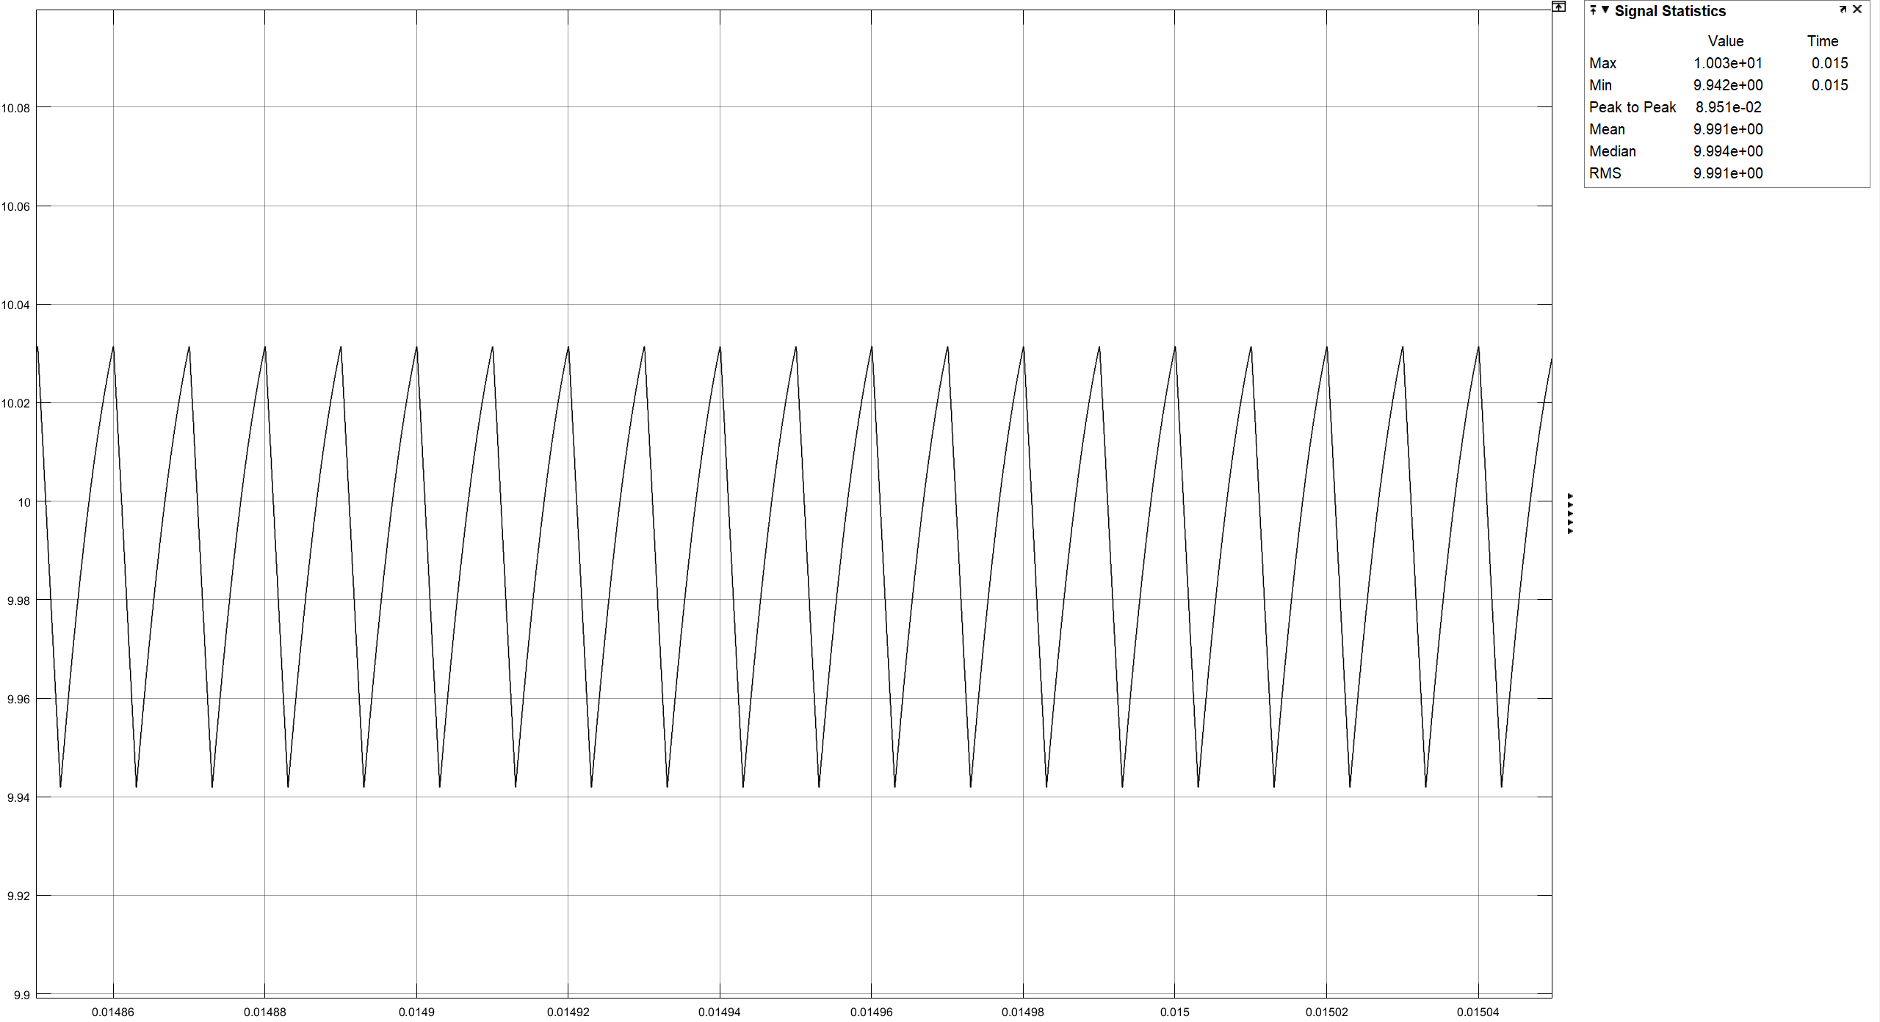

Figure 8: Output voltage waveform of the flyback converter (Vin=24V)

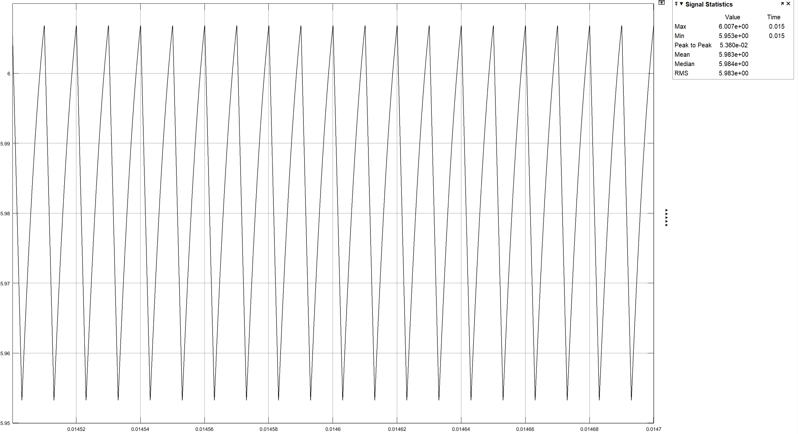

Figure 9: Output current waveform of the flyback converter (Vin=24V)

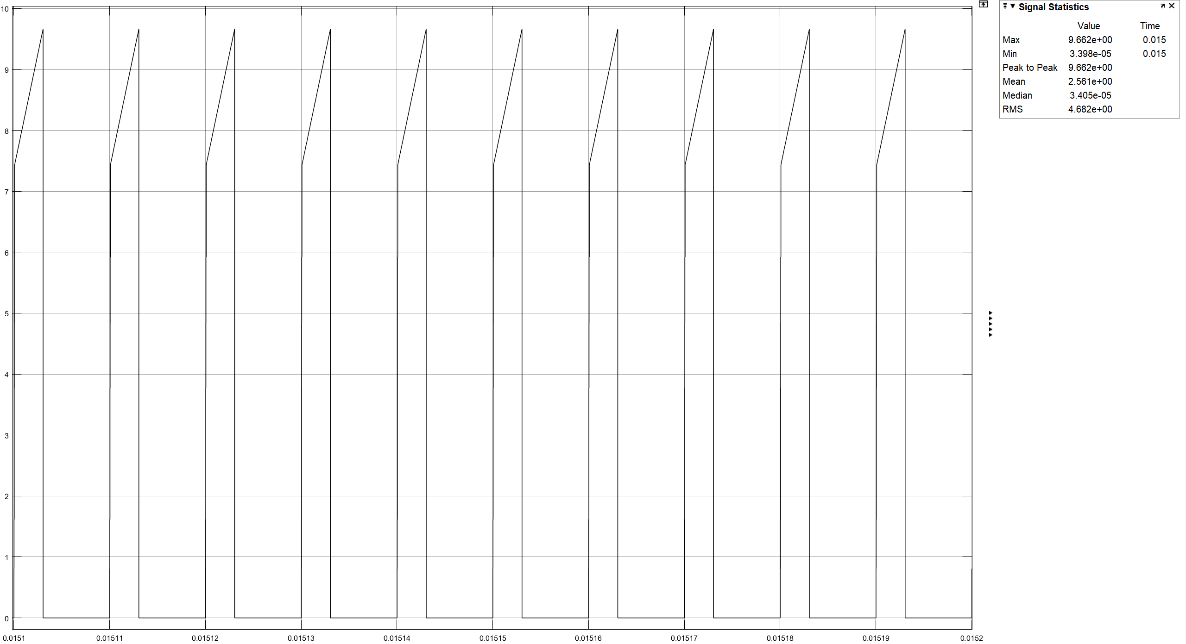

Figure 10: Input current waveform of the flyback converter (Vin=24V)

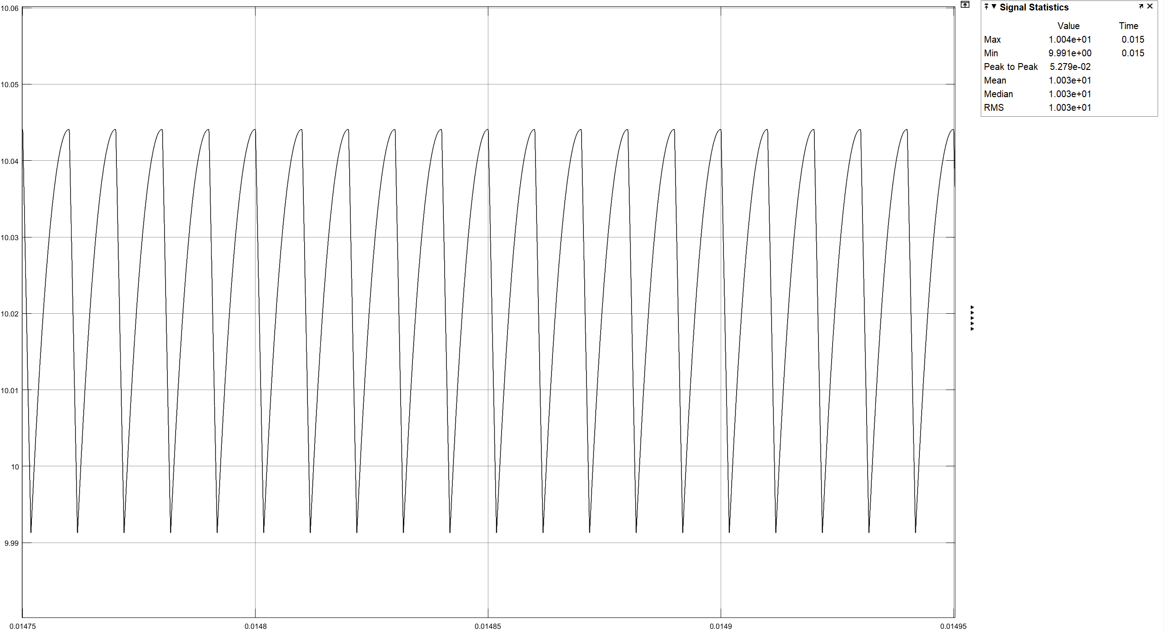

Figure 11: Output voltage waveform of the flyback converter (Vin=48V)

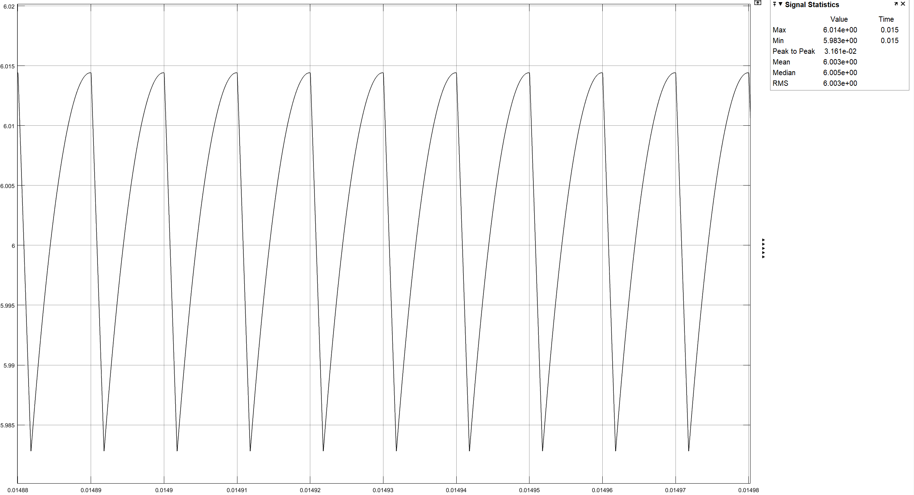

Figure 12: Output current waveform of the flyback converter (Vin=48V)

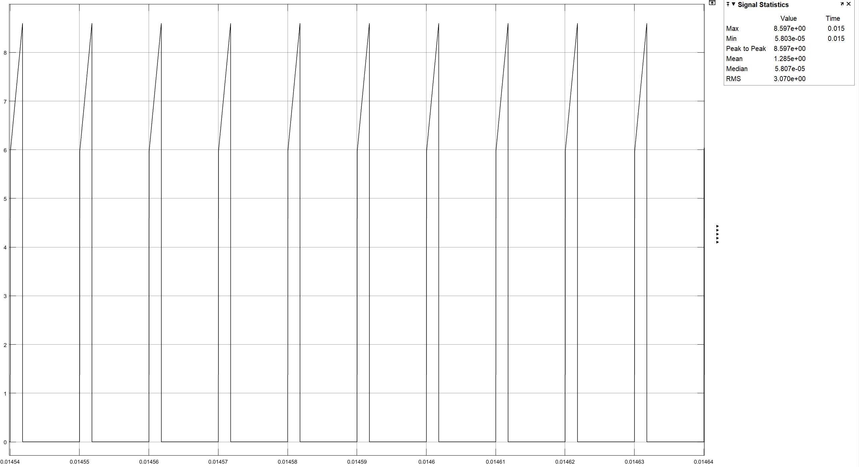

Figure 13: Input current waveform of the flyback converter (Vin=48V)

* Output voltage ripple:

where

**For Vin = 24 V (D=0.295),**

From Figure X, output voltage ripple is 0.089 V and it is same with theoretical result.

**For Vin = 48 V (D=0.1725),**

From Figure Y, output voltage ripple is 0.052 V and it is same with theoretical result.

# Part-d

**Minimum Load Current**

For boundary between DCM and CCM,

where

**For Vs = 24 V and D = 0.295 ,**

**For Vs = 48 V and D = 0.1725 ,**

**Min-Max transformer current**

Assume ripple of the current flowing through the Lm is 40%. The power absorbed by the load resistor must be the same as that supplied by the source. Turn ratio of our transformer is 1.

where Pout = 60 W

**For D = 0.295 and Vs = 24 V,**

Thus,

**For D = 0.1725 and Vs = 48 V,**

Thus,

# Part-e

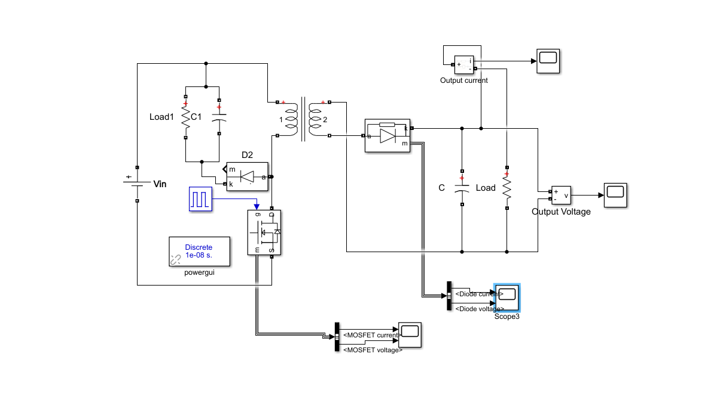

Figure 14:The circuit schematic of flyback converter with snubber

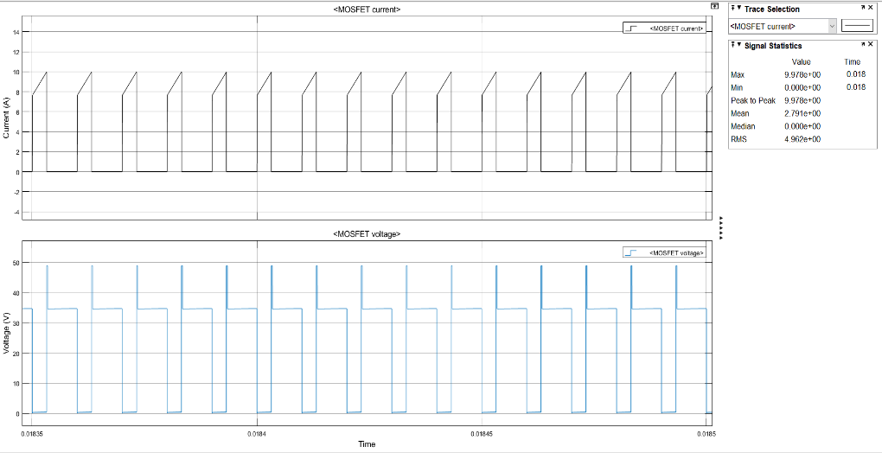

Figure 15:Simulation results of voltage and current waveforms for MOSFET

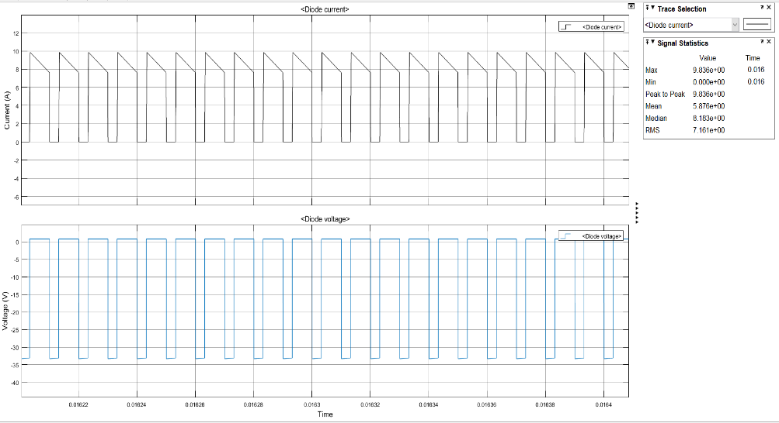

Figure 16:Simulation results of voltage and current waveforms for diode in the secondary side

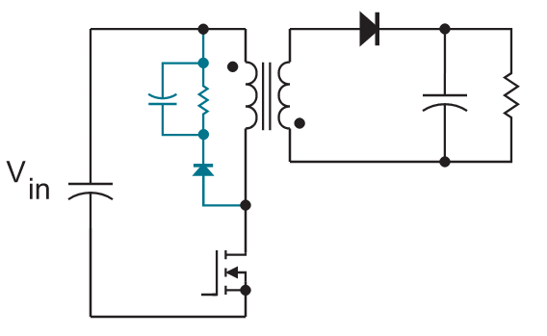

Figure 17:Flyback Converter Snubber

For the snubber,

# Part-f

Simulation results at different loads are following.

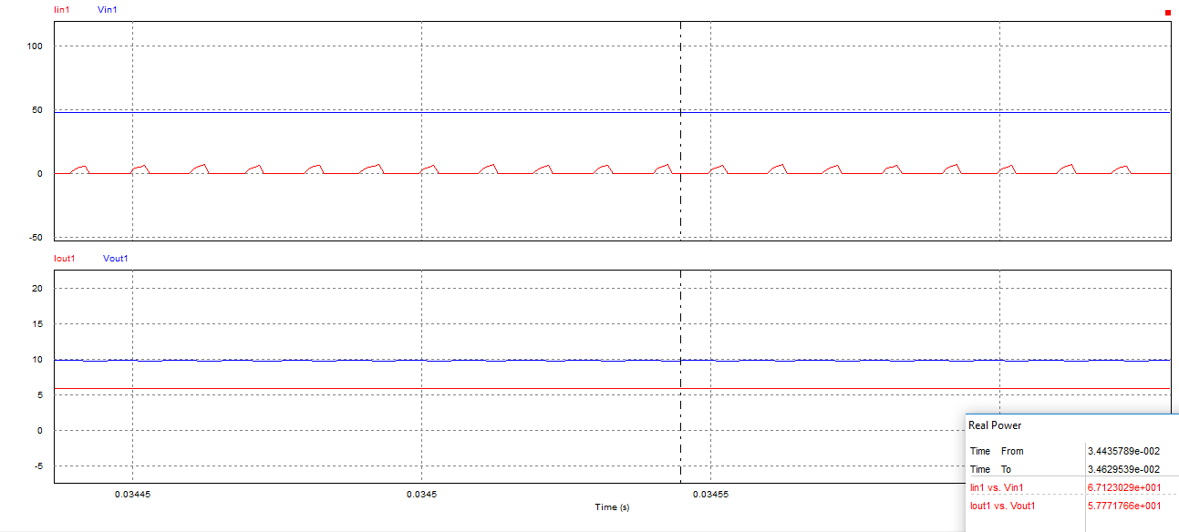

Figure 18:Simulation results at 100% load

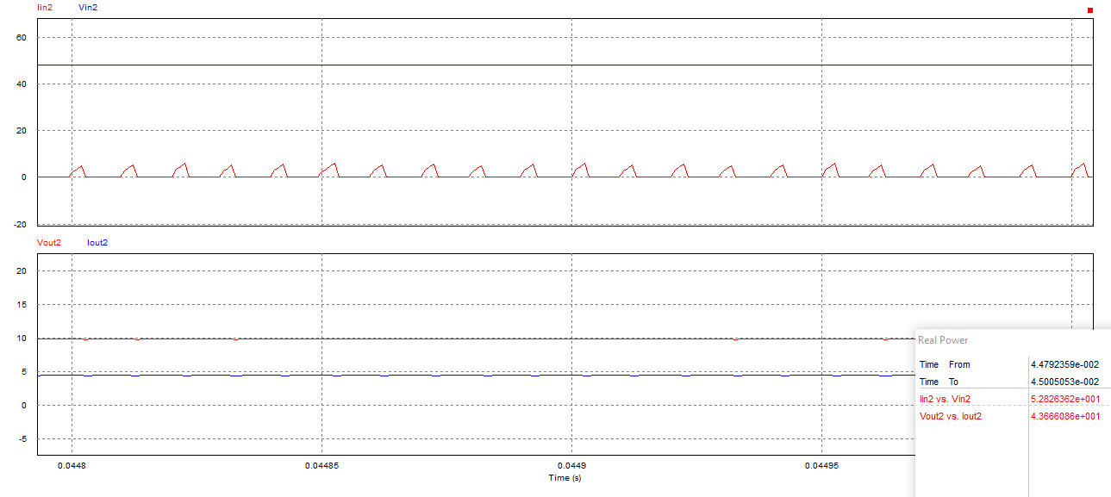

Figure 19:Simulation results at 75% load

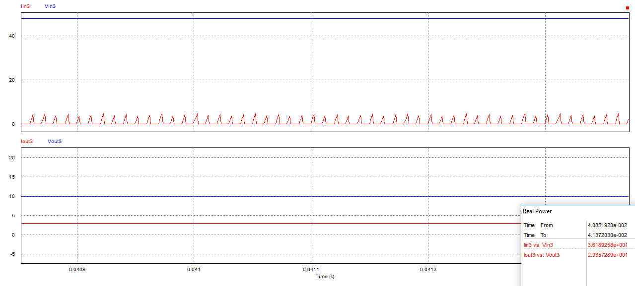

Figure 20:Simulation results at 50% load

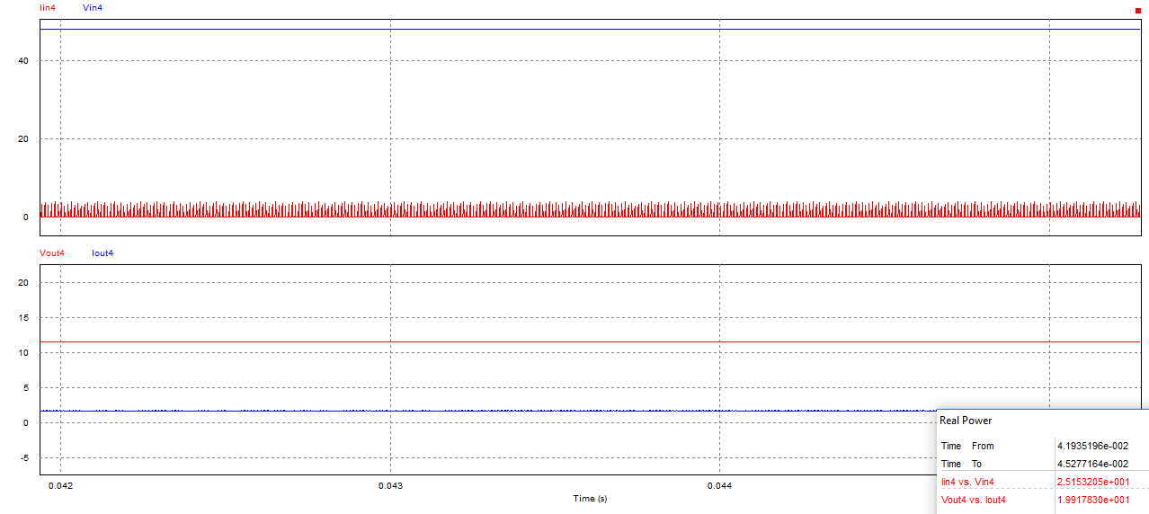

Figure 21:Simulation results at 25% load

Calculated efficiencies are following in the following table. As percentage of load decreases, efficiency is also decreases. These drops results from transformer losses. Transformer losses remain constant while input power is decreasing. Therefore, efficiency decreases.

|  |  |
| --- | --- |
| Load (%) | Efficiency (%) |
| 100 | 86.06 |
| 75 | 82.65 |
| 50 | 81.12 |
| 25 | 79.16 |

# Part-g

At 24 and 48 Volt, simulation results are following figure. Hence, converter works within the given input voltage limits and satisfies the output ripple limits.

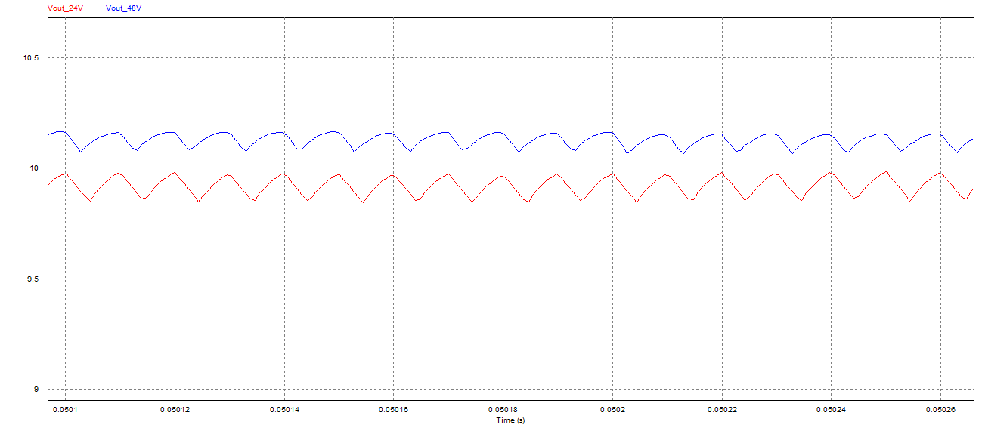

Figure 22: Output voltages for input 24V and 48V

# Part-f

While components are selecting, maximum voltages and currents on components are considered. In part-e, maximum voltage and current was calculated as 50 volt and 35 A respectively. Hence, these conditions are considered and components are selected.On-Off time of switch and diode are also consired. Datasheets can be found following links: [switch](https://eu.mouser.com/datasheet/2/389/stp110n8f7-956371.pdf), [diode](https://eu.mouser.com/datasheet/2/240/DPG60IM300PC-1548649.pdf), [capacitor](https://www.mouser.com.tr/datasheet/2/420/al-kxj-e-140701-514738.pdf).

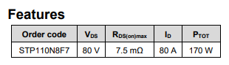

Figure 23: Mosfet's features

Diode’s features are following.

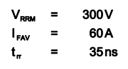

# Reference

* E-Core: <https://www.mag-inc.com/Media/Magnetics/Datasheets/00K4022E090.pdf>
* AWG-10: <https://www.solar-electric.com/learning-center/wiring-cabling/electrical-characteristics-awg-copper-wire.html>
* Kool Mµ B-H curve and core-loss curve: <https://www.mag-inc.com/Products/Powder-Cores/Kool-Mu-Cores/Kool-Mu-Material-Curves>